**AWS administracion**

Creamos una cuenta gmail solo megocios

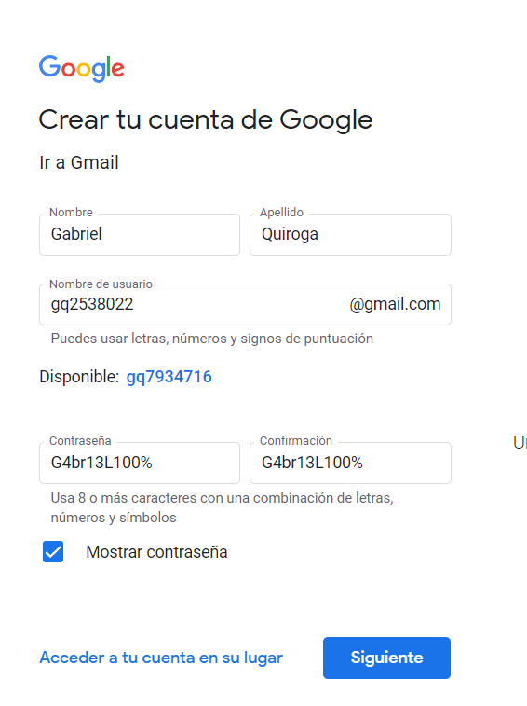

Con el telefono de iq

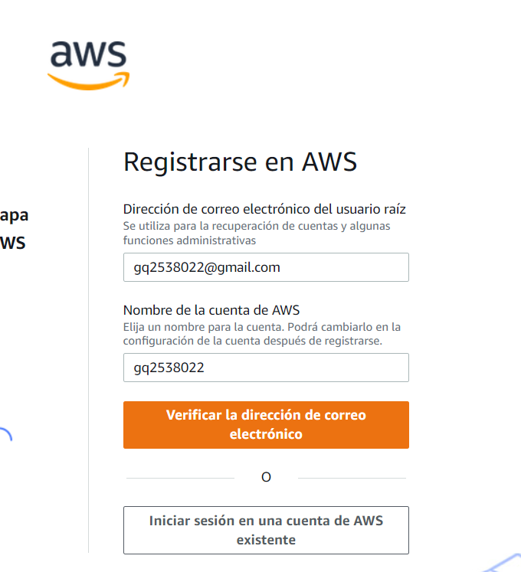

Instalar apache 2

[https://www.digitalocean.com/brcommunity/tutorials/how-to-install-the-apache-web-server-on-ubuntu-20-04-es](https://www.digitalocean.com/community/tutorials/how-to-install-the-apache-web-server-on-ubuntu-20-04-es)

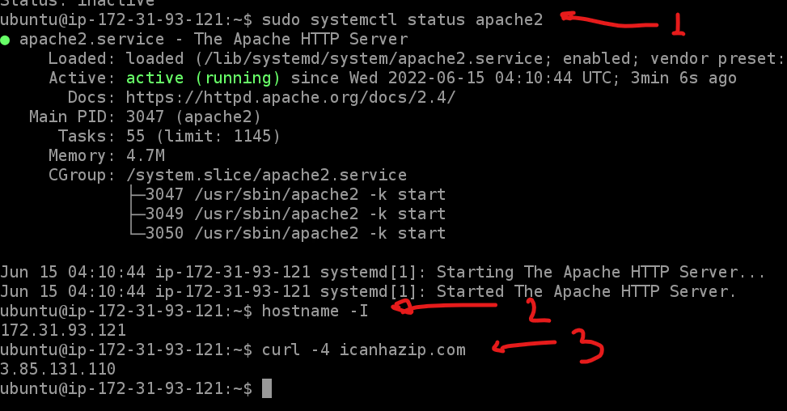

<https://aws.amazon.com/es/premiumsupport/knowledge-center/lightsail-instance-install-lamp-stack/>

<https://www.raulprietofernandez.net/blog/bases-de-datos/como-configurar-mysql-o-mariadb-para-acceder-de-forma-remota>

**Configurar PHPMyAdmin para conectarse a otro servidor**

<https://www.youtube.com/watch?v=Qo6h-fRN1TA&ab_channel=omarmarcelogonzalez>

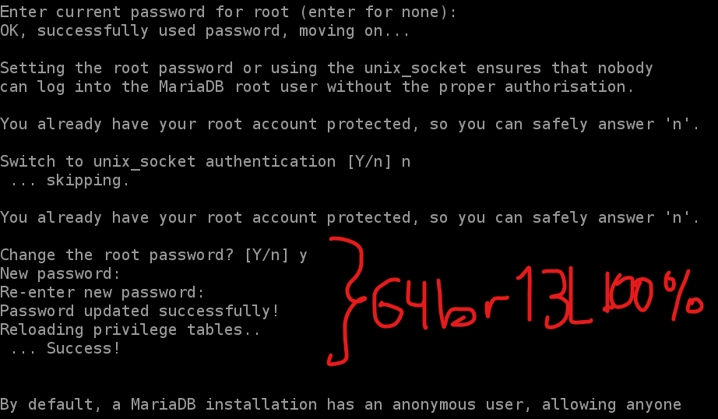

<https://stackoverflow.com/questions/13421463/htaccess-access-control-allow-origin>